 | Christine Sison, BA, MS  christine@swissmonkey.io

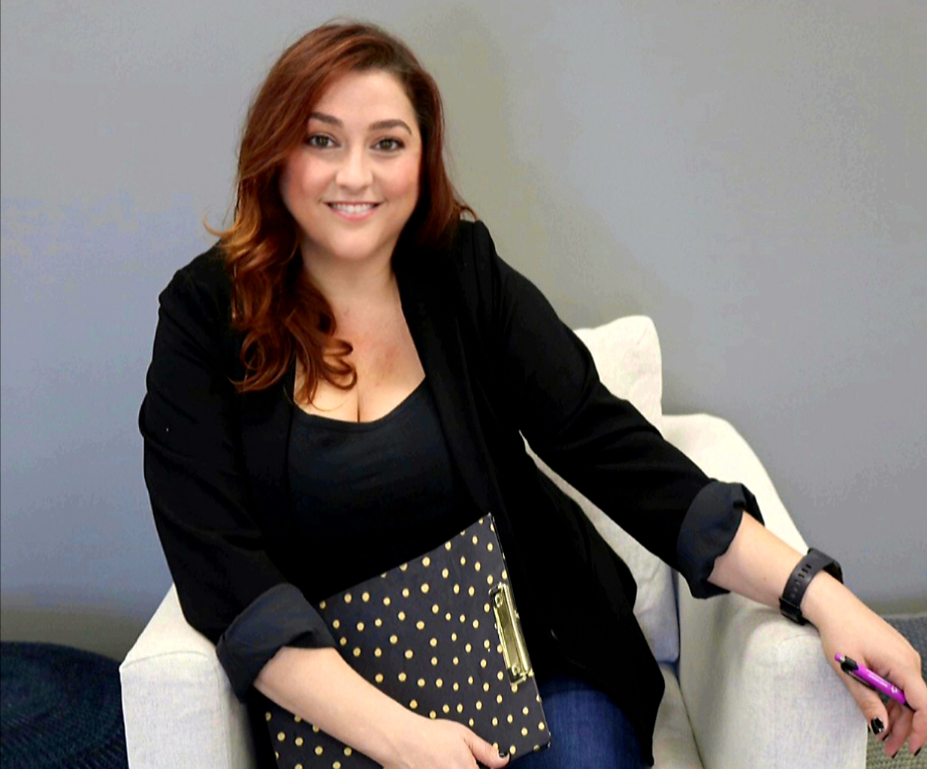 | Rachel Marks, RDA  rachel@swissmonkey.io

Course: Revolutionizing Dentistry: Innovations, Trends, and Expanding
the Role of Dental Assistants

Course Description:
This session will explore cutting-edge trends such as remote workforce integration, AI-powered solutions, and evolving practice models. Learn how these advancements are shaping the future of dentistry and discover strategies to elevate your career by expanding the clinical assistant role to include front office responsibilities. This course is perfect for dental assistants and instructors eager to stay ahead in a dynamic field and embrace opportunities to enhance their skills and impact.

Course Objectives:
- Understand Emerging Trends in Dentistry - Explore cutting-edge innovations such as AI-powered solutions, remote workforce integration, and evolving practice models, and their impact on the dental industry and the role of dental assistants.

- Expand the Scope of Dental Assistant Responsibilities - Learn strategies to enhance career opportunities by incorporating front-office and administrative skills, bridging the gap between clinical and operational roles to support evolving practice needs.

- Prepare for a Dynamic and Future-Focused Career = Develop the knowledge and skills needed to adapt to advancements in dentistry, stay competitive in a changing landscape, and maximize the professional and educational impact of dental assistants and instructors.

Christine Sison
Christine Sison is the CEO of Swiss Monkey, a virtual front office talent deployment and management company. She has built and has managed a dental practice for over 10 years and has her Bachelor of Neurobiology from UC Berkeley and a Master of Health
Policy and Management from the Harvard School of Public Health. Prior to her work in dentistry, she conducted brain tumor research at UCSF, assisted in the integration of IT into clinics and hospitals, and later led the development of community-wide healthcare systems, including telemedicine efforts.

Rachel Marks, RDA
Rachel Marks is a dynamic leader in the dental industry, currently serving as the Chief Growth Officer of Swiss Monkey. Her journey into the dental field began in her teens as a dental assistant, where she discovered a deep passion for the profession. After completing dental assisting school and earning her credentials as a Registered Dental Assistant (RDA), she had the privilege of working alongside exceptional mentors who played a pivotal role in shaping her growth and expertise in the industry. Throughout her career, Rachel has held various roles, including Lead RDA, , Office Manager, Consultant, and Practice Area Director, overseeing multiple locations in pediatrics and specialty dental practices. Her diverse experience encompasses everything from chairside assistance to front office management, allowing her to cultivate a well-rounded skill set. At one point, she managed over nine locations for a private practice service organization in Northern California, demonstrating her ability to thrive in fast-paced environments.

